**Procedure for Opening a New Account with Emkay:**

1) Branches shall visit **ekyc.emkayglobal.com** link and Login through his own Login id and password. Client details will be entered as an email id and mobile number with specific relationship selection and 3 digit OTP will be sent on client email id and mobile number in splits. Client’s signature will get cap

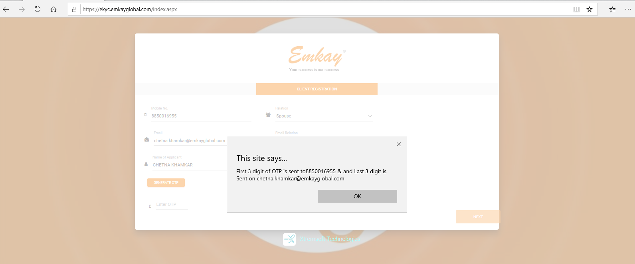

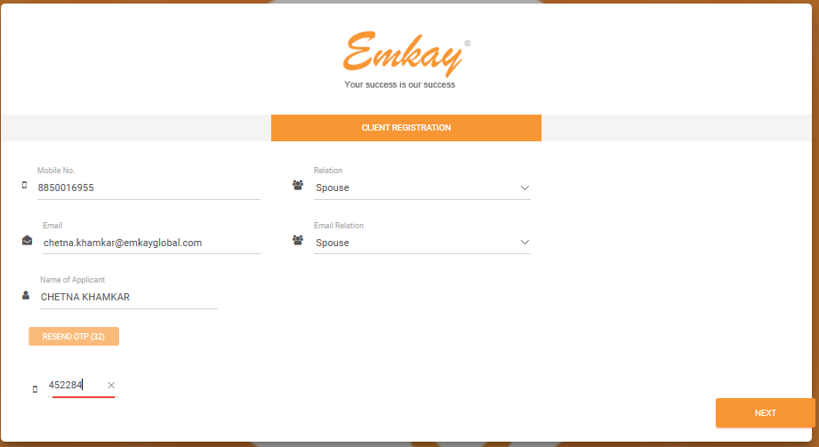

2. Instruction to be followed and which all documents should keep ready for uploading.

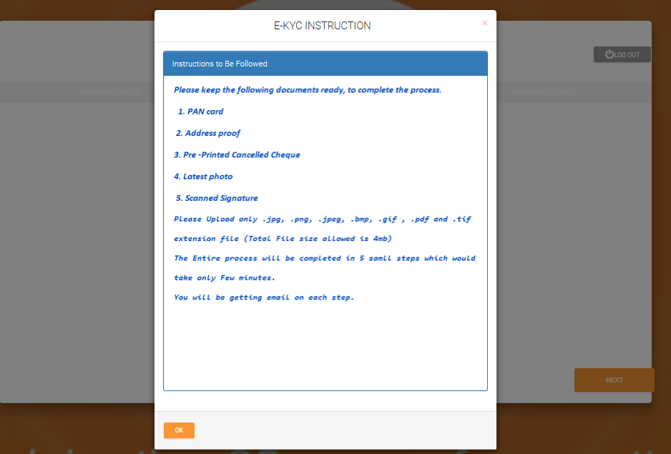

3.PAN Detail shall get verify on PAN portal.

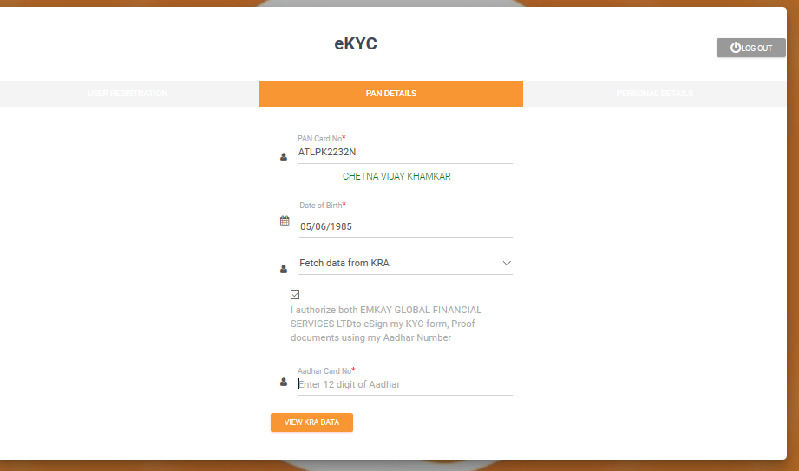

4.KRA detail will reflect post fetching detail.

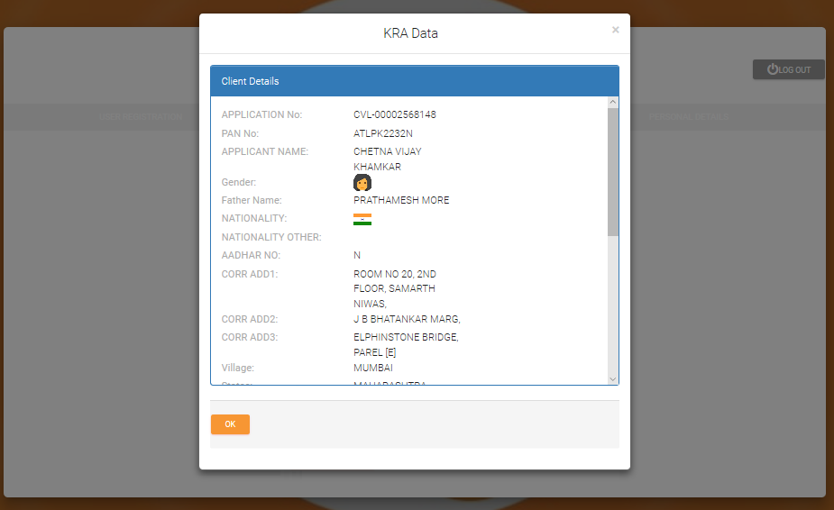

5) Post submission of client data through KRA fetching or through Manual entry one link will be Auto sent to client to capture client’s Live Photograph, Once photo gets captured BY Client, KYC form will get submitted to verifier level and accordingly VIPV link will be sent to client to capture his own video with orginal proof’s

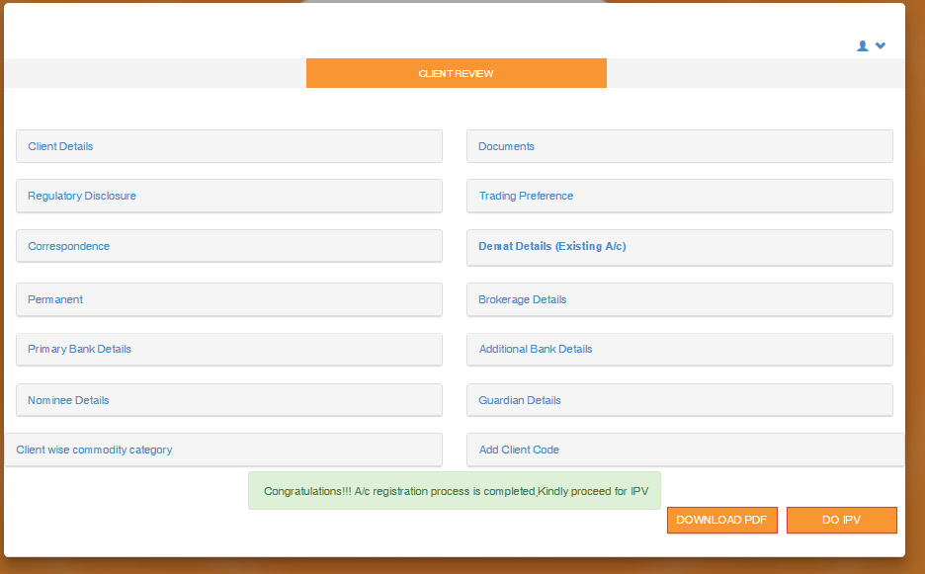

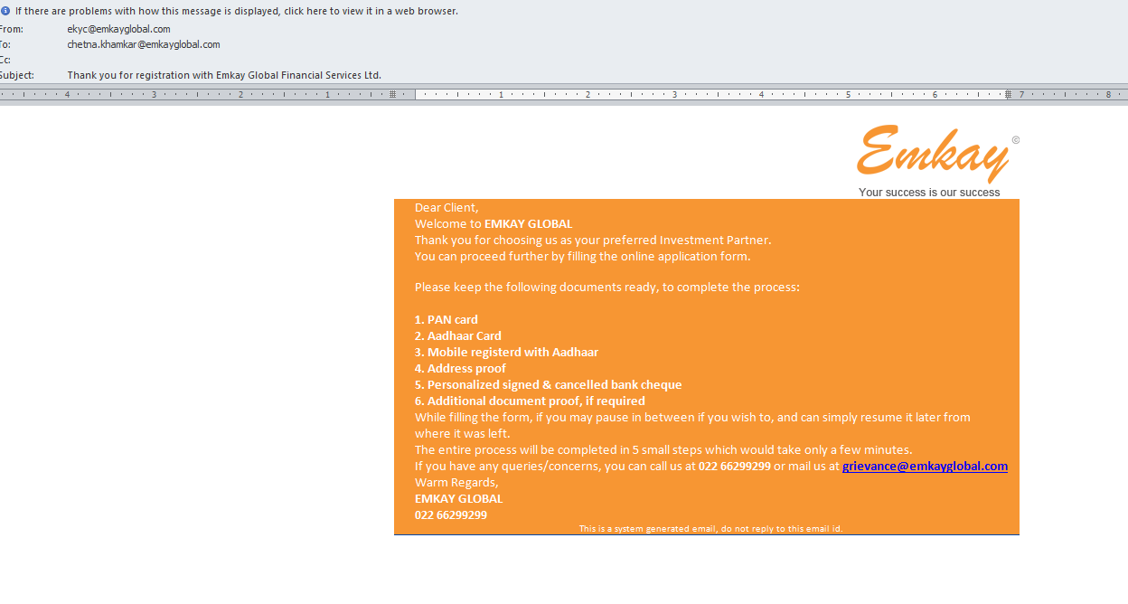.

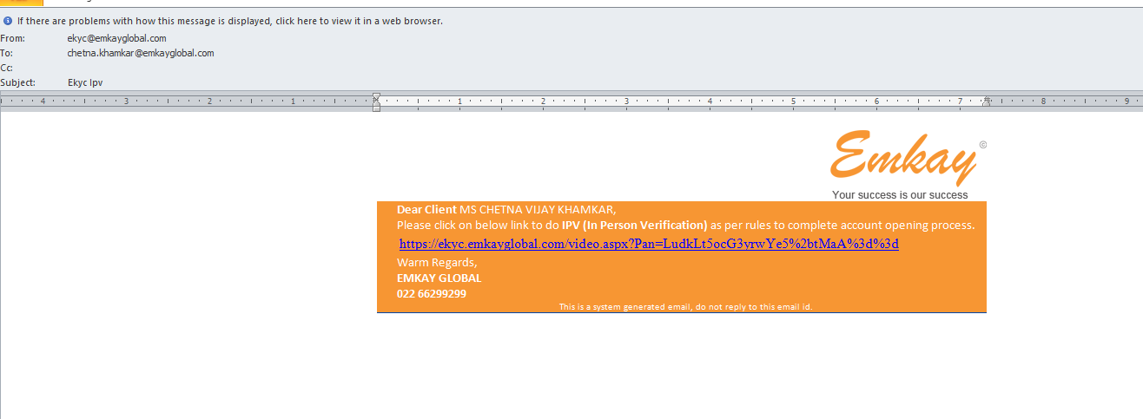

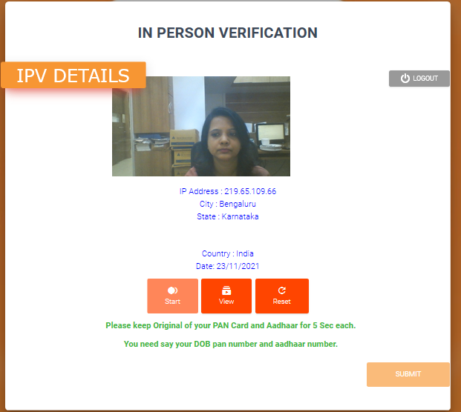

6) On receipt of the Client Online Account opening form, the KYC Team shall perform background verification via C Safe software and any adverse observation if observed; clarification for the same shall be seeked from the respective Branch / Relationship Manager before processing the account.

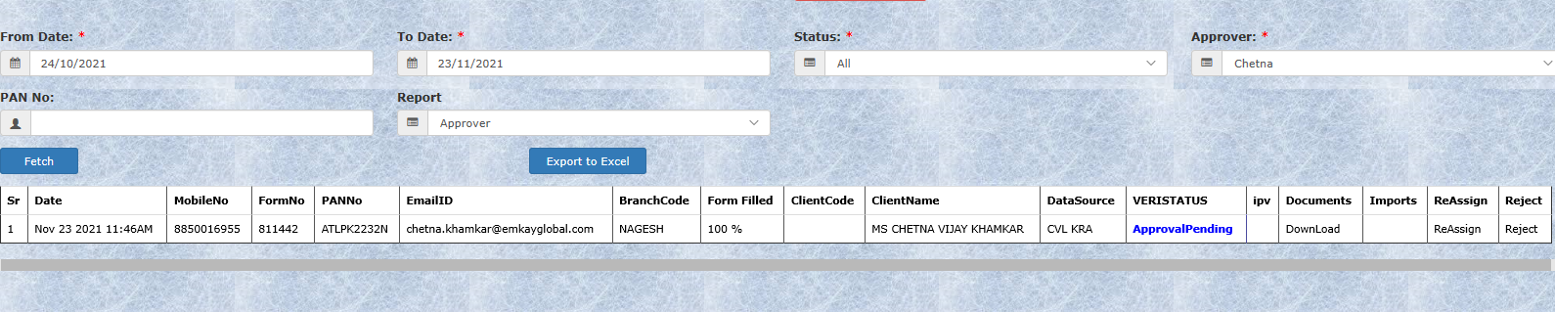

7) Once client detail is Approved, Auto Esign link will be sent on client email id to follow E- Signature process. Once client Esign is successfully done DP ID gets generated.

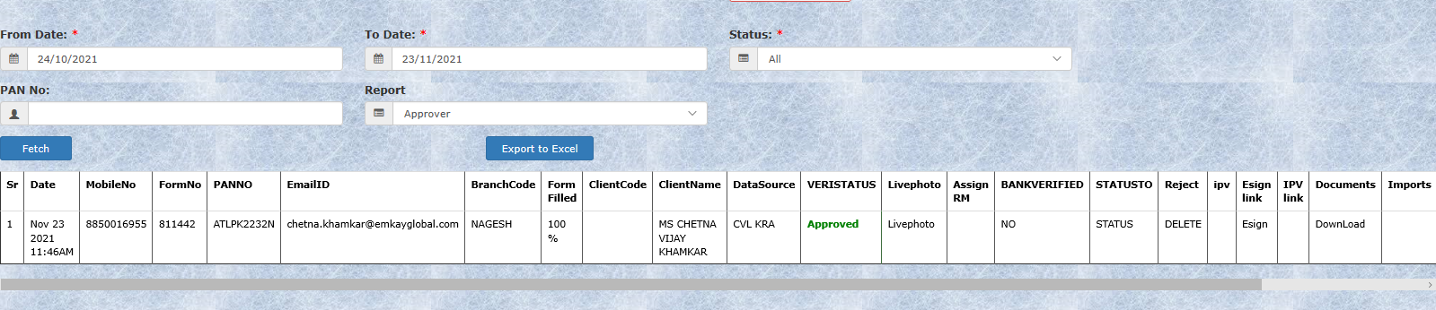

8)Esign link will be sent on client’s email address.

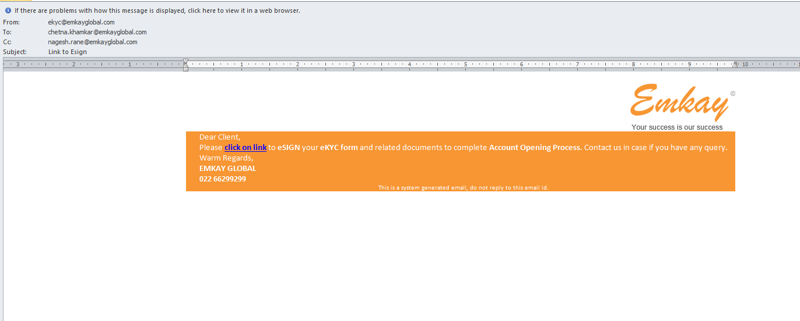

9)Esigner detail page with client detail will get open after clicking on link.

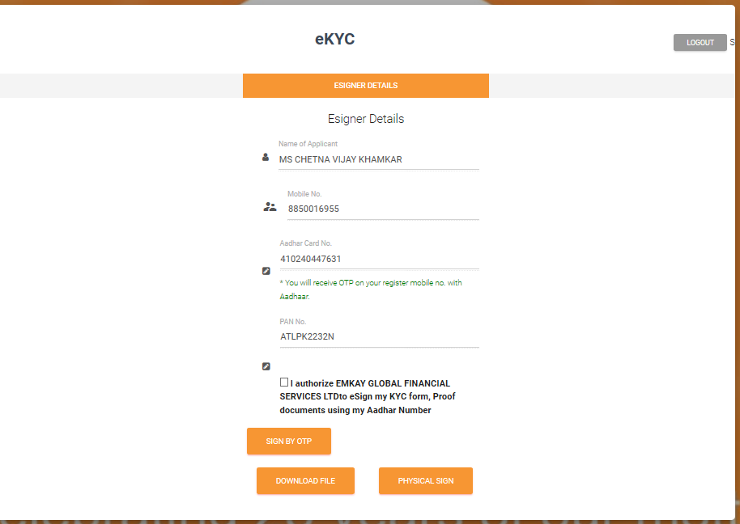

10)Aadhaar Consent page will get open when clicked on **SIGN on OTP**

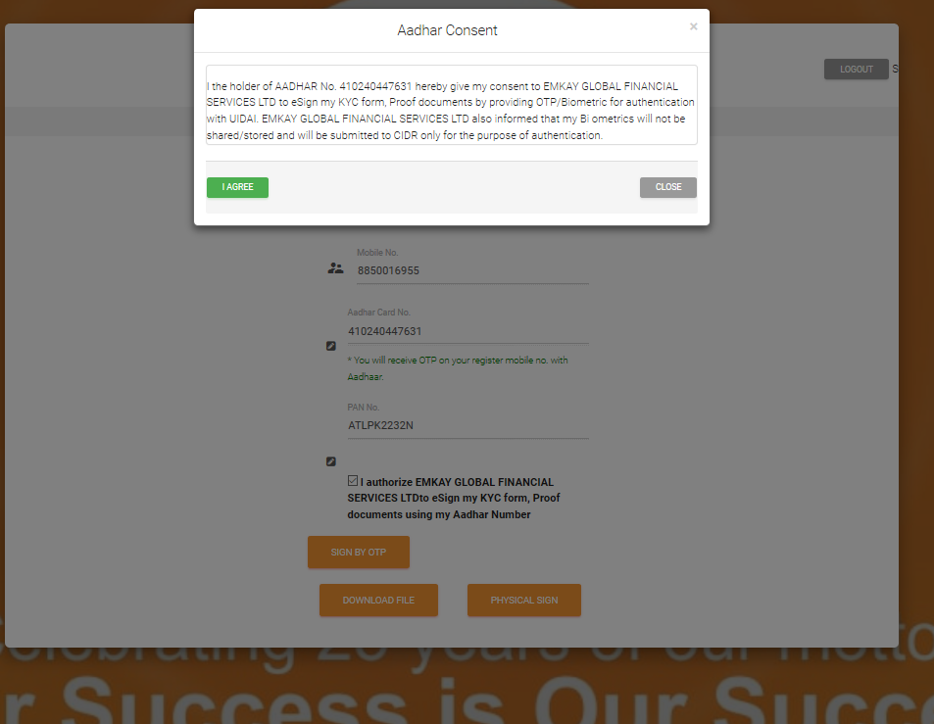

11)Next page will get diverted to Truecopy page.

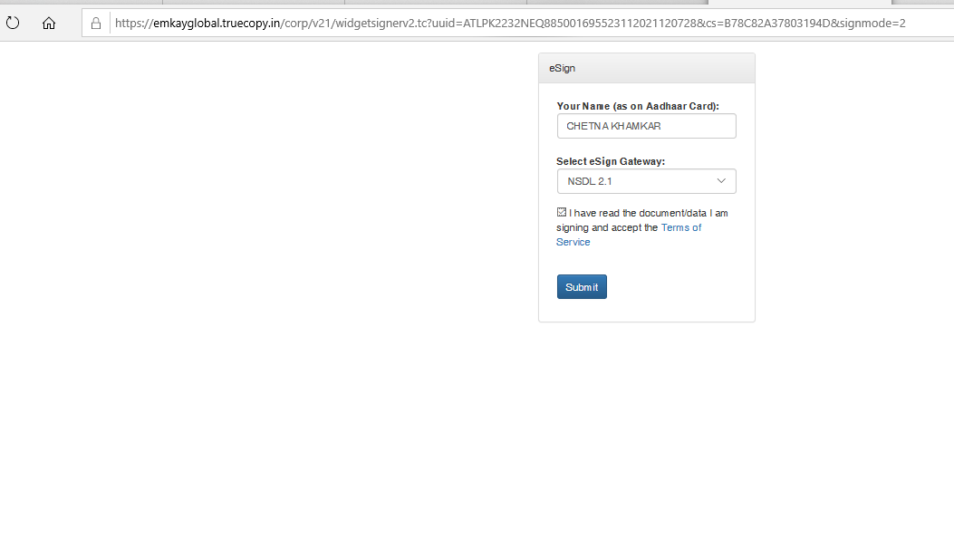

12)After clicking on Submit button Esign page will get open, Click on consent and then feed Aadhaar Number and click on **SEND OTP.**

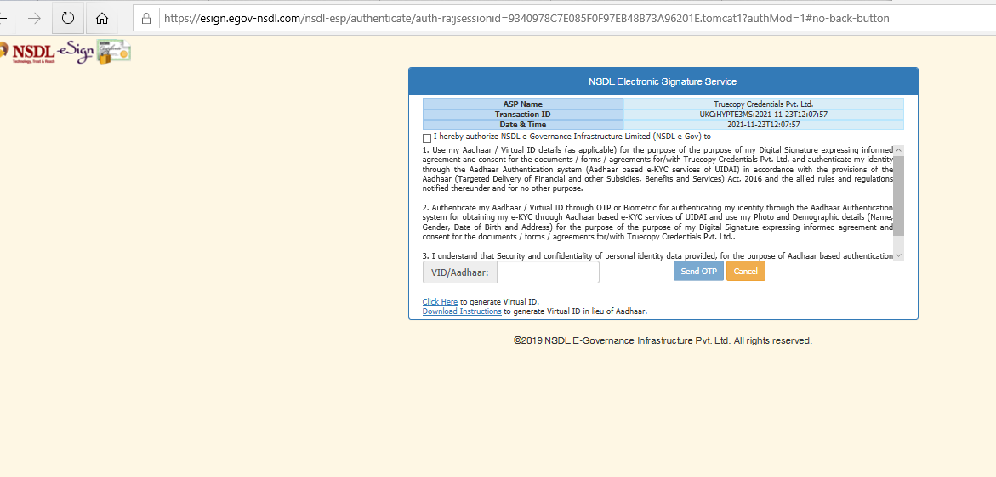

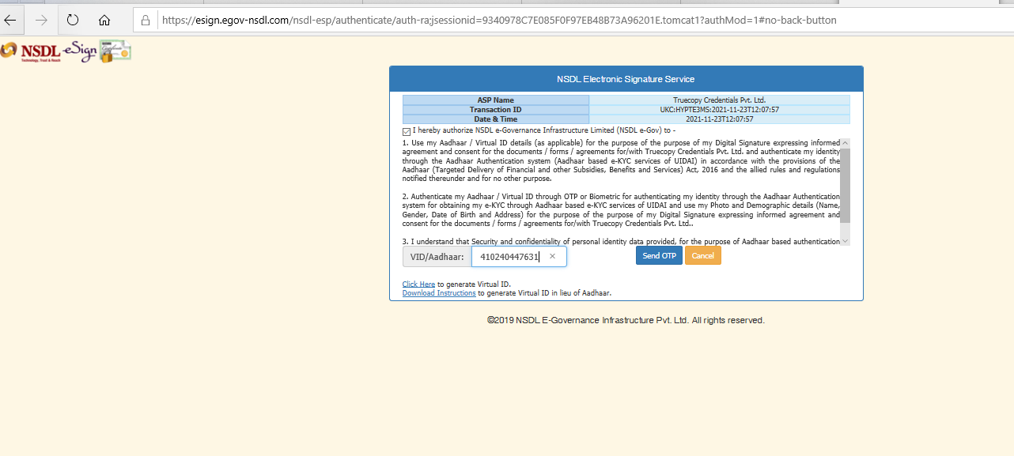

13)OTP Verification is getting done on NSDL site.

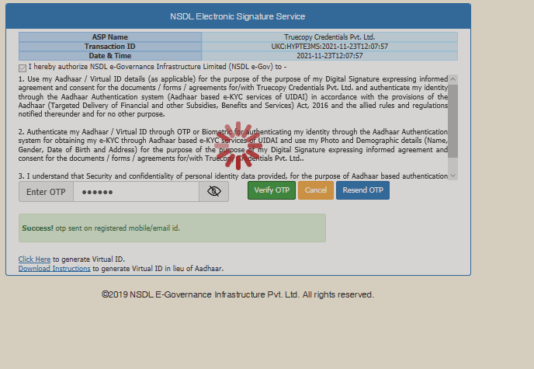

14)Click on the link to view PDF copy with Esign of client, Once Esign is validated account shall get processed by Pushing data in Cross Software.

